EdRev colocará a data ISSN 1094-5296
Libâneo, J. C. Democratização da escola pública: a pedagogia crítico-social dos conteúdos. 28ª edição. São Paulo: Edições Loyola, 2014. Pp. 160 ISBN 978-85-15-00181-1 (impresso)

160p ISBN: 978-85-15-00181-1

Reviewed by
Andréa Maturano Longarezi
Federal University of Uberlândia/Brazil
Roberto Valdés Puentes
Federal University of Uberlândia/Brazil
Leandro Montandon de Araújo Souza
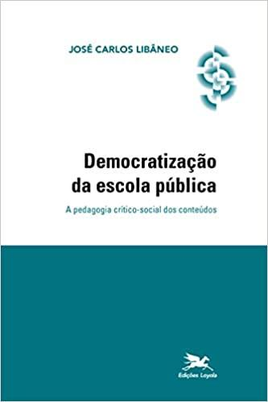
State University of Minas Gerais/Brazil.

Context of the work

It is a reason of great joy and satisfaction to participate in an editorial project that involves the dissemination of the work of important intellectuals of Brazilian education. José Carlos Libâneo, besides being one of the most relevant Brazilian pedagogues and experts in didactics of the late twentieth century and the first two decades of the twenty-first century, is also a personal friend and working partner with whom we have collaborated in the past ten years in many studies and publications in the field of didactics in general and, above all, of developmental didactics.
Libâneo (1945, Angatuba, São Paulo/Brazil) graduated in Philosophy (1966), received a master's degree in Philosophy of Education (1984), a doctorate in Philosophy and History of Education (Brazil, 1990) and a post-doctorate in Education (Spain, 2004); he has an extensive teaching career at Federal and Pontifical Catholic University of Goiás and is currently a professor in the Graduate Program in Education at PUC/Goiânia, as part of the Line of Research Educational Theories and Pedagogical Processes (LIB NEO, 2014; LONGAREZI; PUENTES, 2020; PUENTES; LONGAREZI, 2020).

Photo: José Carlos Libâneo

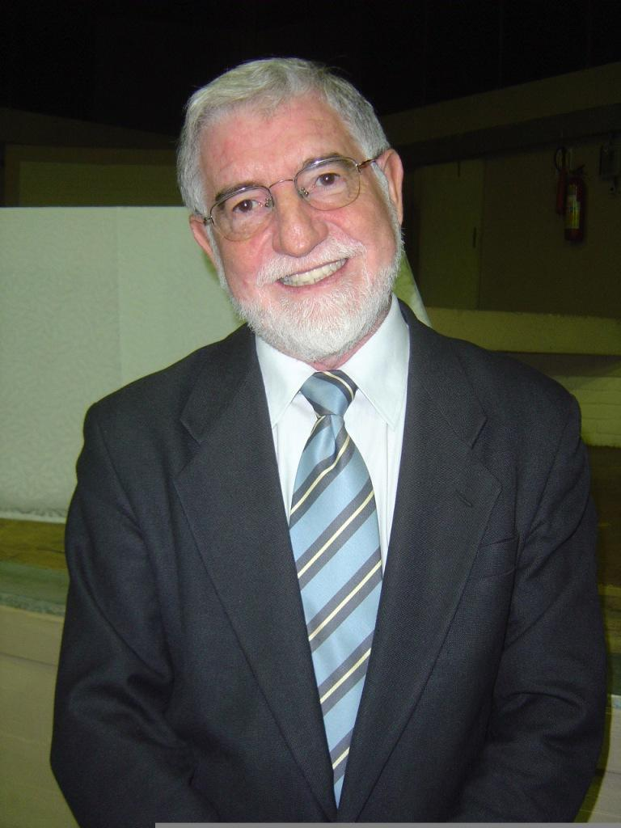
Source: http://letrasunifacsead.blogspot.com/p/jose-carlos-libaneo-concepcoes-de.html

The genesis of his thinking can be found in the contradictory conjuncture and ideological-political tensions that characterized the 1970s and 1980s in the defense of democratization and social transformation. The main focus of his work is on four fundamental pillars: Pedagogy, Didactics, democratization of public schools, and social transformation. His contributions are expressed in a vast and solid production in the area that, over more than fifty years of intellectual activity, is near 200 academic works (articles, chapters, and complete books) and 100 works as an advisor (post-doctorate, doctorate, master's degree, and undergraduate research).
Above the recorded formative and bibliographic legacy, it is necessary to recognize the political, intellectual, and academic expressiveness that marks the author's entire trajectory. An analysis of his scientific production makes it possible to identify some aspects that are constituted, by the systemic and transversal nature of this production, in nuclear units of his thought: 1. the defense of the democratization of society; 2. the socio-political purpose of education and public school as mediators of the democratization process; 3. the emphasis on the curricular content of the school as a fundamental component of this mediation; and 4. the learning of these contents as a key element for human disalienation, a sine qua non condition for the formation and development of a more egalitarian society.
However, even when these aspects are manifested in the form of nuclear units throughout his work, the two first ones, related to the philosophical-political-ideological positioning, underwent few changes in relation to the references and defended theses; the two last ones are especially revealing of the movement of the rise of his thought, particularly in the theoretical and methodological dimensions of Didactics. In other words, while the philosophical-political dimension has always had its foundations anchored in practically the same epistemological bases, with slight variations over such a long period, his theoretical and methodological thinking reveals the process of scientific production and overcoming that best marks his academic-intellectual trajectory.
Thus, the current level of development reached by the author's theoretical and methodological thinking, specifically in the didactic field, evidences changes concerning, specifically, his conception about school content and the its modes learning, which allows us to establish, at least, three stages that mark his thinking in the period from 1976 to 2020 (LONGAREZI; PUENTES, 2020; PUENTES; LONGAREZI, 2020): the first one, named Marxist didactic thinking under a philosophical perspective (1976-1990), the second one, historical-cultural Marxist didactic thinking (1991-2001), and the third one, developmental Marxist didactic thinking (2002-2020).
These stages are characterized by the strong influence of Marxist theses on democracy, education, school, teaching, learning, etc. However, in the first one, the approach to the field of Didactics is carried out under a more philosophical bias, mainly based on the theses produced outside the former Soviet Union, especially by authors who lived and wrote in the context of capitalist societies, such as K. Marx, F. Engels, G. Snyders, A. Gramsci, D. P. Ausubel, M. Manacorda, A. Vázquez, and B. Charlot; in the second, an initial approach to theoretical references with psychological foundations is observed, particularly represented by authors of the Soviet period, such as L. S. Vigotski and A. N. Leontiev; and, in the third one, a developmental approach to Didactics is already delimited, based on Soviet psychologists and experts in didactics, represented not only by L. S. Vigotski and A. N. Leontiev, but also by S. L. Rubinstein, D. B. Elkonin, P. Ya. Galperin, V. V. Davidov, etc., and also European authors who follow this perspective, such as the Finnish author Yrjö Angström (2002), the Danish authors Seth Chaiklin (2001) and Mariane Hedegaard (2002), among others.
Democratization of Public School: the critical-social pedagogy of contents (Edições Loyola, 1985) is, without a doubt, the most important work by the author throughout the first stage (Marxist didactic thinking under a philosophical perspective: 1976-1990) and probably one of the most relevant books in the history of Brazilian Education, Pedagogy, and Didactics, written and published after the military dictatorship and in the beginning of the democratic opening process in the country. This work, together with Didática (1992), Organização e gestão da escola (2000), Educação escolar: políticas, estrutura e organização (2003), and Pedagogia e pedagogos, para quê? (1998), integrates the list of the most cited Libâneo’s works and, strange as it may seem, the number of consultations and citations has only increased in the last few years, which makes it a classic study due to its freshness, topicality and validity.
Published by Editora Loyola (São Paulo) in 1985, the work was already in its 28th edition in 2014, which only confirms the enormous and permanent welcome it had among Brazilian researchers and professors. By number of editions, this work is only comparable to also extremely relevant and popular Brazilian books, for instance, Didática (J. C. Libâneo, 1991, 34th edition), Escola e Democracia (D. Saviani, 1984, 43rd edition), A didática em questão (V. M. F. Candau, 1984, 28th edition), and Metodologia do trabalho científico (A. J. Severino, 1975, 24th edition, Cortez Editora).

Structure and content of the work

The work brings together six independent texts produced in the form of communications at scientific events, book chapters and/or articles published in journals from 1982 to 1984 and focus on the development of key ideas about pedagogical-didactic issues. The present review was carried out based on the 28th edition, published in 2014. Its main purpose was to address, from the theoretical-epistemological point of view, key ideas selected by the author, such as mediation, historicity, social practice, and transmission/assimilation of contents, analyzing them from their pedagogical-didactic implications.
The first chapter "Pedagogical trends in school practice" (initially published in 1983 in Revista Ande) draws attention to the fact that pedagogical practices, consciously or not, follow theoretical-methodological assumptions, whose orientation is revealed and revealing of particular conceptions of human and society. It is possible to notice the teaching pedagogical posture based on common sense prescriptions or adopting perspectives that install themselves as pedagogical fads. The author criticizes the content of teacher education undergraduate courses, warning that the curricular components, as they are developed, do not consistently include a theoretical instrumentalization work that grounds pedagogical practices in the light of the various learning and teaching theories or, if they deal with it, do not do it in a way connected to school reality.
The text proposes, therefore, to present the various trends that, fundamentally, were evident in the Brazilian school context in the beginning of the 1980s. Taking as a criterion the socio-political conditions that guide the different pedagogical perspectives, the author classifies them into two groups. In the first one, there are approaches that were classified as representative of a Liberal Pedagogy, which include the 1. Traditional, 2. Renewed Progressive, 3. Renewed Non-Directive, and 4. Technicist perspectives. The second one includes qualified focuses as representative of a Progressive Pedagogy: 1. Liberating, 2. Libertarian and 3. Critical-social of contents. The author characterizes the role of the school, the content, the method, and the teacher-student relationship for each perspective and defends a critical-social pedagogy of contents.
The second chapter "Knowing, knowing how to be, knowing how to do: the content of pedagogical doing" (published in 1982 in Revista Ande), confirms the philosophical foundations of the first stage of his thinking, precisely, the Marxist didactic thinking under a philosophical perspective (1976-1990). In this sense, it defines the teacher as a professional concerned with doing, precisely, that critical doing that validates the theories about the school, theories that are involved in the functioning of the school itself and that turn to the interests of the subordinate classes of society. Such critical doing presupposes education as a manifestation of concrete social conditions, in which the development of class consciousness is hindered by dominant groups. Therefore, this critical doing needs to tension the conformist education of the masses, revealing the school as a possible instrument for the intellectual progress of the working class.
It identifies and criticizes perspectives that are incapable of making the school fulfill this function, naming them pseudo-solutions. They are: 1. reduction of school work to political action; 2. democratism; 3. anti-technical criticism; 4. pedagogical cynicism or self-denial of the educator's role, and 5. reformism of the pedagogy undergraduate course. It bases this criticism in the defense of the construction of a social pedagogy that is responsible for the formation of the conscience about the class contradictions, that problematizes the social reality, that seeks the development of the individuals in the processes of social intervention. The teacher, in this perspective, was constituted from a solid theoretical education, based on disciplines that consider the school routine and on studies capable of articulating teachers of different education levels. Thus, it emphasizes the perspective that defends the public school as a space for democratization, which plays a central role in the feasibility of a new society project, and which has an essentially political nature, locus of teaching practice that, operationally theoretical and practical, is emancipatory in its formative objectives.
The text "Educational orientation, public school, and critical-social pedagogy of contents", presented as third chapter is the synthesis of the speech made, by the author, in a Brazilian conference in 1984, in which he historicizes the struggle for the public school as a right of the entire population to this space of transmission of the produced culture and situates the pedagogical practices in the context of different trends that characterize Liberal and Progressive pedagogies, presented in a similar way to what was done in the first chapter. It brings up the educational orientation situated as a product of new pedagogy, in which it identifies four theoretical trends: functionalist, non-directive, phenomenological-existential, and technicist.
Although apparently contradictory, it demonstrates how educational orientation, even emerging as a progressive perspective, has an incompatible focus with progressive premises. Aiming to think about the tasks of the educational advisor in this perspective, the text analyzes the purposes of the school, the pedagogical and social practices, the teaching as the student's encounter with the study subject, the educational means, and the awareness of the teacher, taken from the critical-social pedagogy of contents.
The fourth chapter, "Educational psychology: a critical evaluation", was originally published in the book Psicologia Social — O homem em movimento, organized by Silvia T. M. Lane and Wanderley Codo, in 1984. Its initial reflections critically point out the limitations of educational psychology in teacher education, given the precariousness of the care offered to school practice. They indicate the possibility of this limitation being found in the various scientific reductionisms among the sciences that seek to explain the educational act, sociologism, psychologism, and pedagogism. From the contradictions characterized by these reductionisms, JC Libâneo reveals the centrality of his historical-dialectical materialist philosophical foundation, demonstrating that the educational act is configured in the intercession of psychological, pedagogical, and socio-political phenomena, like all human activity, it is a historical construction given in the relationship between individuals and society.
In society, it is possible to find conditions of educability that, as an external influence, affect individual development. The school takes the educational objective of promoting the appropriation, by students, of cultural contents capable of contributing to the reduction of social inequalities. A critical social Pedagogy is characterized, therefore, as practice of syntheses of a knowledge that is learned in the intervention of the subjects with their realities and that, as it is elaborated, modifies the apprentice subjects themselves. Therefore, he attributes to the school institution the function of promoting maximum child development, only possible in the simultaneity between individual and social development, that is, between the domain of the knowledge that they personalize and the capacity to integrate and act in the society. He concludes his reflection by explaining the qualities of the enabling elements of the critical-social Pedagogy of contents, which are 1. a Psychology of social relations; 2. the prerequisites for learning; 3. the contents-methods, and 4. the school environment.
The fifth chapter, "Notes on the pedagogical-didactic issue and educational policy", concentrates ideas that were also presented in a Brazilian event, in 1984, and published in the Annals of III Brazilian Conference of Education. J. C. Libâneo analyzed perspectives that fueled the debate about the reformulation of Pedagogy courses and other teacher education majors, identifying three main different positions related to education: 1. understood as a socio-political practice; 2. strictly analyzed in its technical-pedagogical aspects; and 3. its synthetic understanding as a pedagogical-didactic activity politically related to the totality of the social. From this analysis, he highlights the specificity of the philosophical orientation of critical-social Pedagogy of cultural contents, precisely in the public school’s role of disseminating knowledge that instrumentalizes the popular classes' struggle for their emancipation.
The education socio-structural determinants are thus recognized simultaneously with the ways in which pedagogical activities enable the critical re-elaboration of school knowledge by students, which is the reason why they need to be intimately linked to their concrete life conditions. Thus, education is linked to social practice oriented to human emancipation. The educational practice that originates pedagogical theories is validated in the way that, when returning to practice, the pedagogical-didactic objectives become consciously oriented, characterizing what the author names as a dialectical reconciliation of the primacy of student activity and the content of what is taught by the teacher's practice. Naturally, it demands systematic work by the teacher, an active assimilation by the student, mediated by the content of school knowledge.
The book’s sixth and last chapter, "Didactics and historical-social practice (An introduction to the foundations of Didactics)", also published in Revista Ande, in 1984, was originally a communication made in some pedagogical meetings of teachers of Federal University of Mato Grosso and Federal University of Uberlândia, in the same year. In it, there is an effort to gather some elements so that the foundations of the teaching work are elaborated, even if in an introductory way, in the perspective of the critical-social pedagogy of contents, in order to reveal “[...] the possibilities of a critical-social didactica, in the version that conceives teaching as an intentional and systematic transmission of cultural and scientific contents” (LIBÂNEO, 2014, p. 137).
In order to advance in this purpose, the teacher is presented as the student's learning mediator and the methodological guidelines comprise three “steps”: 1. Initial guiding situation (syncresis); 2. operational development (analysis); 3. integration and generalization (synthesis); proposed as a movement of the syncretic, passing through the analytical, towards the synthetic. In methodological terms, there is a demarcation of the didactic field by means of the inductive method when it is assumed that it must go “[...] from the empirical, pass[ing] through the abstract, to get to the concrete, that is, the thought concrete." (p. 154).
In synthesis, the work gathers conceptual elements and discusses aspects related to the foundations of a Critical-Social Pedagogy of Contents, as one of the branches of Progressive Pedagogy. In its scope, it is possible to find the defense for the democratization of the school as a space for democratization of society by "[...] the dissemination of schooling for all, placing cultural and scientific training in the hands of the people as an instrument of struggle for their emancipation." (LIBÂNEO, 2014, p. 136). It carries in its own nomenclature the mark of content as an instrument of struggle for social equality, for instruction and domain of systematized knowledge. It is important to highlight, however, that this content is the one selected for the wealthiest layers of society, even when proposed that it relates to popular realities. In the historical context of the work, the content defended as an “instrument of struggle for emancipation” is encyclopedic and has an empirical nature, which will posteriorly be supplanted by what the author will defend, based on the Soviet psychologist and expert in didactics V. V. Davidov, as being the content of the school: the theoretical thinking, which includes the formation of the scientific concept and mental actions.

Philosophical, pedagogical and didactic foundations of the work

From the philosophical point of view, as stated at the beginning, the work is supported by the Marxist theses of authors such as K. Marx, G. Snyder, A. Vázquez, D. Saviani, G. J. García Galló, and B. Charlot. Precisely, the term “Critical-Social Pedagogy of Contents”, which gives its name to the subtitle of the book, is directly inspired, as recognized by Saviani (2020), in Progressive Pedagogy by G. Snyders (1974). According to Saviani (2020, p. 38),

the ‘primacy of contents’ as a criterion for distinguishing a progressive or left-wing pedagogy from a conservative one (SNYDER, 2978, p. 309). It is seen that, inspired by a Marxist author, J. C. Libâneo points to the theoretical horizon of Marxism.

In this initial phase of development of J. C. Libâneo's philosophical thought, the domain of the assumptions of historical-dialectical materialism is present, even without reaching the level of elaboration and deepening achieved in later stages.

With this, the work maintains a Marxist view as its reference, in which the role of the school was interpreted, on the one hand, by the angle of criticism of social inequalities and, on the other, by the search for overcoming these inequalities, human emancipation, and the liberation from class oppression, among other things, via the access and permanence of the poorest children in schools followed by a process of struggle for the destruction of alienating social relations that take place in the context of capitalist society and the construction of a new society, even when it is not made explicit that it is a socialist society.
From the pedagogical point of view, the book is inspired on the theses by M. Manacorda and B. Suchodolski. It is, firstly, a critical analysis of the educational models that influenced the Brazilian pedagogical practice; second, the democratization of the public school through the democratization, above all, of teaching, understood as the accomplishment of a pedagogically and didactically “differentiated” teaching work, which means, in Libâneo’s (2014, p. 12) words:
[...] helping students to express themselves well, to communicate in different ways, to develop an interest in studying, to master school knowledge; it is about helping them in the formation of the social personality, in their organization as a collective. In short, it is about providing them with critical knowledge and know-how, as a precondition for their participation in other instances of social life...
Essentially historical-dialectic materialistic, the Critical-Social Pedagogy of Contents is anchored in the understanding that the historical movement of society is a human construction, derived from class contradictions, fundamentally transforming and potentially emancipatory. Even though this construction takes place in a historical and social context that has been determined since the past, human activity affects it in the present, exploring a new and transformed future. That is why the Critical-Social Pedagogy of Contents assumes the concrete and present historical and social conditions as its starting point. It is in these conditions that class tensions will manifest and that the school will fulfill its function, understanding the future as a synthesis of the present tensions that, potentially, can make a less unequal society emerge in the future.
As confirmed from the didactic point of view, the work represents a milestone of the author's philosophical Marxist thought (LONGAREZI; PUENTES, 2020; PUENTES; LONGAREZI, 2020) in which a perspective of education that transforms social reality is revealed, based on disalienation by popularizing school knowledge. In this sense, a renewal of pedagogy is advocated through a renewal of content, understood as a collective patrimony of society and, in this sense, as “[...] element of cultural elevation, basis for the critical insertion of the student in the social practice of life” (LIBÂNEO, 2014, p. 13).
The knowledge historically produced by humanity is presented, in the work, as an instrument of power when it is maintained as privilege and property for only a portion of society. In this sense, the content assumes a character of possession to be reappropriated as a collective patrimony of society, as a form of struggle by the popular classes. It is under this ideological and political force that the Critical-Social Pedagogy of Contents, defended by the author, will be grounded; which is why “"It is not a matter of [...] understanding the pedagogy of contents as pure uncritical transmission, nor understanding it as a cultural invasion, nor even as something to be spontaneously incorporated through the path of individual discovery." (LIBÂNEO, 2014, p. 15). Here is the cell of a thought by the author that will accompany all of his work: the role of the school as an institution that can provide humanization processes through the appropriation of generic human culture.
In this perspective, the work is consolidated by its idea of democratizing the public school, through

[...] expansion of educational opportunities, dissemination and critical re-elaboration of knowledge, improvement of educational practice aiming at the cultural and scientific elevation of the popular strata, contributing, at the same time, to respond to their most immediate needs and aspirations” (LIBÂNEO, 2014, p. 12).

However, in the scope of this perspective, the didactic processes that make up this idea are still grounded on the basis of teaching through the expository method, since the primary function of the school, as defended in the work, is directed to the transmission of knowledge and its appropriation by the students, in which the relationship of the educational subjects (teacher and students) is presented as a synthesis of what the author will call “binomial transmission/active assimilation” (LIBÂNEO, 2014). In this perspective, the role of the teacher oscillates, in the work, between transmitting and mediating the content. This apparent opposition hides, in fact, its real meeting point. The idea of mediation in the work converges to the understanding of transmission:

The acquisition of knowledge as an instrument for the active insertion of the student in the global dynamics of social transformation requires the integration of two simultaneous movements: transmission of knowledge and active assimilation by the student. On the one hand, the teacher is placed as a carrier of organized knowledge, methodological resources, and provider of objective conditions for the teaching activity. But, on the other hand, there is the student as an active subject of knowledge. It is the core of the pedagogical relationship: dialectical conciliation between the primacy of the subject's activity in learning and the object of knowledge and its methodological requirements of transmission, through the mediation of the teacher. (LIBÂNEO, 2014, p. 153)

The method as a didactic process, in the defended perspective, which derives from the content, as stated,

, “[...] goes from the empirical, passes through the abstract, to get to the concrete, that is, the thought concrete.” (LIBÂNEO, 2014, p. 154). The nature of this method is, therefore, inductive and still focuses on a traditional teaching perspective, through the transmission of content. In this sense, the didactic thinking expressed in this work, later supplanted by the author himself (LONGAREZI; PUENTES, 2020; PUENTES; LONGAREZI, 2020), is in the historical context of the book based on the inductive method, from which it is argued to take social practice as a principle, to move to a level of abstraction that takes place in relation to the content explicitly introduced by the teacher, assuming a return to practice as thought concrete. This methodological proposition follows the phylogenetic, and not ontogenetic, sense of knowledge production.

In short, the book is a landmark of Brazilian didactic thinking, represented, particularly, by the educational militancy undertaken by the author. In view of the ideological-political and didactic-pedagogical position of the time, the work registers the defense of a Critical-Social perspective of Contents, from which the school assumes its role of social transformation, taking into account the condition of enabling the egalitarian appropriation of the content that resonates in the students' lives. In this perspective, it defends that the contents have human and social significance; defends the subordination of methods to the content, in which it is proposed to deposit knowledge that is external to the students or considers it spontaneous to them; and defends that the method assumes the confrontation between the student's experience and the socially produced knowledge.
Appreciating the importance of the work in the historical landmark in which it was produced and recognizing its strength and magnitude revealed by the relevant influence it had on Brazilian pedagogical thought (in the 29-year period, from 1985 to 2014, the book had 28 editions, almost one per year), it is also necessary that we locate it at the frontiers of the development stage of the author's didactic thinking (LONGAREZI; PUENTES, 2020; PUENTES; LONGAREZI, 2020). It implies treating its advances and limits in the historical context in which they were produced and assuming that the aspects defended by the author regarding the importance of the content and the method resulting from it, remain only in terms of its form, but are outdated as to their concepts and fundamentals. Here is an invitation to read the book and the author's current production in order to analyze the pedagogical science produced in his/its movement.

References

LIBÂNEO, José Carlos. Democratização da escola pública: a pedagogia crítico-social dos conteúdos. 28o edições. São Paulo: Edições Loyola, 2014.
LONGAREZI, Andréa Maturano; PUENTES, Roberto Valdés. A ascensão do pensamento didático desenvolvimental em José Carlos Libâneo (1976-2020). In: SUANNO, Marilza Vanessa Rosa; CHAVES, Sandramara Matias; ROSA, Sandra Valéria Limonta (Orgs.). Educação como prática social, didática e formação de professores: contribuições de José Carlos Libâneo. Goiânia: Espaço Educativo, 2020, p. 189-247.
PUENTES, Roberto Valdés; LONGAREZI, Andréa Maturano. José Carlos Libâneo: gênese e desenvolvimento de seu pensamento didático. Ensino em Revista, Uberlândia, v. 27, p. 1275-1305, 2020.
SAVIANI, Dermeval. José Carlos Libâneo: Pedagogia, didática na democratização da escola pública. In: SUANNO, Marilza Vanessa Rosa; CHAVES, Sandramara Matias; ROSA, Sandra Valéria Limonta (Orgs.). Educação como prática social, didática e formação de professores: contribuições de José Carlos Libâneo. Goiânia: Espaço Educativo, 2020, p. 29-47.
SNYDERS, Georges. Pedagogia progressista. Coimbra: Almedina, 1974.

About the Authors of the Review

Andréa Maturano Longarezi Postdoctoral degree in Education by University of São Paulo/BR. Professor at School of Education, Federal University of Uberlândia. Coordinator of the Study and Research Group on Developmental Didactics and Teacher Professionalization (GEPEDI) and editor of Obutchénie: Journal of Didactics and Pedagogical Psychology. E-mail: andrea.longarezi@gmail.com

Roberto Valdés Puentes Doctoral degree in Education. Professor at School of Education, Federal University of Uberlândia. E-mail: robertovaldespuentes@gmail.com

Leandro Montandon de Araújo Souza. Doctoral and Master’s degree in Education (UFU), Specialist in Educational Orientation (Dom Alberto), Teaching degree in Social Sciences (UFU) and Pedagogy (FAEL). Professor at State University of Minas Gerais - UEMG, integrating the line Public Policies and Management in Basic Education. E-mail: leandro.montandon2008@gmail.com



O Copyright e retido pelo/a o autor/a (ou primeiro co-autor) que outorga o direito da primeira publicação à revista Education Review/Reseñas Educativas/Resenhas Educativas. Más informação da licença de Creative Commons encontram-se em http://creativecommons.org/licenses/by-nc-sa/3.0/ Qualquer outro uso deve ser aprovado em conjunto pelo/s autor/es e por AAPE/EPAA. AAPE/EPAA é publicada por Mary Lou Fulton Institute Teachers College da Arizona State University .

Nota: Os pontos de vista ou opiniões apresentadas nas resenhas de livros são exclusivamente do (s) autor (es) e não representam necessariamente os da revista.


Education Review/Reseñas Educativas/Resenhas Educativas está no Facebook (https://www.facebook.com/pages/Education-Review/178358222192644) e no Twitter @EducReview

