EdRev will insert date ISSN 1094-5296

Angulo, A. J., ed. (2016). Miseducation: A history of ignorance-making in America and abroad. Baltimore: Johns Hopkins University Press.

Pp. 374 ISBN: 978-1421419329

Reviewed by Elizabeth Currin
University of Florida
United States

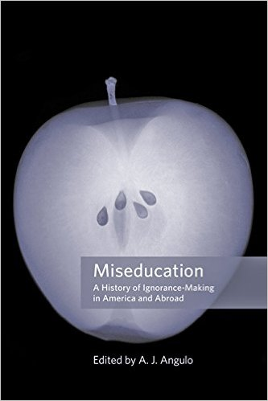
“Exploding myths,” A. J. Angulo (2016) warns, “is dangerous business,” yet his edited volume’s historical case study approach is said to “ease us into an understanding of the way the mythmaking process works, evolves, adapts, and takes surprising detours” (p. 340). True to his word, Miseducation: A History of Ignorance-Making in America and Abroad manages just that: the collection of essays is at once dangerously explosive and delightfully easy to read. The former characteristic is owing to the impressive array of topics that Angulo’s contributors address; the latter quality speaks to Angulo’s knack for arranging these independently strong pieces into a powerfully provocative whole.
He begins this ambitious task by providing readers with a solid introduction to agnotology, the study of ignorance. Establishing ignorance as a discernible presence—even a choice—rather than an absence or lack, he implores us to pay close attention to its markers, boundaries, and purposes. After all, Angulo argues, “Our lives take us in directions that require us to become less ignorant about some aspects of life and increasingly ignorant about others” (p. 1), yet scholars have ostensibly ignored ignorance. Angulo aims to extend historian Robert Proctor’s work, urging capable readers to join him. In part, this goal recognizes the distinct role historians of education can play in the burgeoning field of ignorance studies. However, Miseducation does not spare that population in its finger-pointing, and rightly so.
Part I, “Legalizing Ignorance,” reinforces the notion that ignorance exists by acknowledging instances when it was blatantly encouraged to suit various interests, such as the veritably encoded achievement gap in the antebellum South. Author Kim Tolley uncovers in Georgia’s 1829 antiliteracy law “a fear of the intellectual equality of blacks and whites” (p. 29). Fear, it seems, goes hand-in-hand with ignorance-making, as Karen Graves makes clear in her chapter, a refined distillation of her prior work, And They Were Wonderful Teachers: Florida’s Purge of Gay and Lesbian Teachers (2009). Appearing in concert with the other contributions in Angulo’s volume, Graves’s scholarship benefits from an agnotology lens, underscoring educational institutions’ persistent need to confront their own responsibility for the production of ignorance.
In keeping with the theme of Part I, Adam Shapiro charts the multifaceted strategies of antievolutionists, establishing a sound precursor for Kevin Elliott’s subsequent chapter. Elliott, like Shapiro, draws heavily upon the work of Robert Proctor, as well as Naomi Oreskes and Erik Conway. Admittedly, it is challenging to delineate where their ideas end and Elliott’s begin, although he aptly relies on their scholarship to advocate for critical science literacy regarding climate change, polemically reminding readers of the tobacco industry’s nefarious machinations. Elliott’s chapter thus exemplifies how a robust understanding of the past can have an instructive contemporary impact. Indeed, Part I invites readers to view laws more scrupulously, carefully considering how omissions or occlusions may lurk beneath the sterile surface.
Part II of Miseducation explores mythologized ignorance, a subtler if not more sinister variety than the preceding section’s legally bound ilk. Daniel Perlstein, for instance, tells the story of Deweyan protégé Elsie Clapp to show Progressivism for the “complex amalgamation of social welfare, social solidarity, and social control” it was (p. 124). Clapp’s public school project in 1930s West Virginia relied on an epistemological positioning that avoided class conflict. Perlstein’s critique of Clapp thus shows that educators are not immune to ignorance-making, and the other contributors in Part II follow suit. Eileen Tamura casts a wide net for the complicit in her treatment of the model minority myth. Apart from the scholarly community, Tamura notes how educators who have bought into the myth were consequently ignorant of their students’ needs, overlooking aberrations from the dominant narrative. Tamura’s distinction between collective and selective memory surrounding the incarceration of Japanese Americans during World War II is a particularly powerful addition to the larger agnotological discussion.
Adam Laats and Donald Warren successfully round out Part II. Laats offers a thorough portrait of the “cultural occlusion” wrought by Christian history textbooks—“a systematic attempt” to efface mainstream knowledge (p. 179). His conclusion regarding the effects of such curricula reinforces the larger theme in Miseducation of ignorance as a discernible and deliberate presence rather than an inadvertent and innocuous lack. Coming on the heels of Laats’s chapter, Warren’s meta-examination of the history of education’s own history is especially effective. He turns a sharp critical eye on his field, presumably above the fundamentalist fray at work in the prior chapter and yet no less prone to produce and perpetuate ignorance.
Because Warren’s chapter is a history of histories, Angulo might have chosen to end the volume there. Having extensively traversed time and space, the reader likely feels sufficiently well versed in agnotology at the end of Part II, but Part III, “Nationalizing and Globalizing Ignorance,” plays a pivotal role. Lisa Jarvinen’s chapter, which opens the final section, is a brisk and fascinating exploration of fin de siècle American annexationists’ woefully miseducative empire denial. At the time, Jarvinen claims, “While much was made of the supposed ignorance of Filipinos, it was commonly accepted that Americans knew little to nothing about the Philippines” (p. 218). It is entirely possible this is still the case: despite alarming news reports of late, Rodrigo Duterte is not exactly a household name.
Trafficking in more familiar and equally enthralling territory, Lisa Pine examines miseducation during the Third Reich, when both propaganda and pedagogy served Nazi aims. She presents convincing evidence of the Gestapo’s unfounded ubiquity, offering a salient global counterpoint to the misleading American myths in Part II. Her analysis of the means whereby Nazis “constructed and preserved ignorance among the German population by not only banning and censoring information but also replacing and obscuring knowledge” (p. 264), such as the widespread use of homogenizing textbooks, bears an instructive resemblance to Adam Laats’s work in the prior section. Soli Vered and Daniel Bar-Tal’s chapter on Israel’s strategic use of masternarratives also has far-reaching implications, demonstrating the dangerous power of schools to shape and perpetuate national identity. The authors’ enumeration of the Israeli Ministry of Education’s tactics recalls Adam Shapiro’s and Kevin Elliott’s respective chapters, further confirming A. J. Angulo’s hunch that miseducation is a vast and vital albeit underexplored domain.
Angulo’s book is likely to give us all pause to consider our own implicit and explicit culpability in the long and storied history of ignorance. Eileen Tamura succinctly expresses what her fellow contributors also suggest: “ignorance, created and sustained, provide[s] injurious consequences” (p. 156). Dongping Han and Stephen Samuel Smith, in their nuanced portrayal of miseducation both during and about China’s Cultural Revolution, similarly warn that “ignorance might indeed function as a prime catalyst in history rather than as a side-effect or consequence” (p. 332).
The volume would, however, benefit from greater attention to the hidden and null curricula, especially since the majority of its authors wink and nod in that direction. A comprehensive history of global ignorance-making would seem to warrant discussion of what Eisner (2002) claims are the three curricula all schools teach—explicit, prescribed coursework and its attendant standards and assessments; implicit or hidden lessons that go well beyond the textbook page or even classroom walls; and the null curriculum conveyed through glaring omissions, echoing Angulo’s sense that ignorance is dangerously palpable and substantive. Weaving curriculum theory through the agnotological approach would capitalize on this connection and strengthen the book’s implications for educators, although one of Miseducation’s many assets is the authors’ embrace of a broad definition of education, inviting a concomitantly wide audience.
Nevertheless, Angulo’s primary audience seems to be historians of education, who arguably stand most to gain from an expansion of agnotology. In the final chapter, perhaps intentionally dubbed “Reflections” instead of the more definitive “Conclusion,” he urges a methodological shift within his discipline, “a project worthy of a generation of scholars” (p. 343) and thus necessarily dependent on the pipeline from K-12 schools to higher education. His overarching goal for the volume, to “energize a generation of students to learn about how ignorance is produced, diffused, maintained, and regulated in domestic and foreign contexts” (p. 347), is lofty but noble. Miseducation: A History of Ignorance-Making in America and Abroad has as much to do with the present and future as it does the past; is as applicable worldwide as it is in the United States; and should invite a diverse set of readers who can answer the call to stop ignoring ignorance.

References

Eisner, E. (2002). The three curricula that all schools teach. In The educational imagination: On the design and evaluation of school programs (3rd ed.). Upper Saddle River, NJ: Merrill Prentice Hall.

Graves, K. (2009). And they were wonderful teachers: Florida’s purge of gay and lesbian teachers. Urbana: University of Illinois Press.

About the Reviewer

Elizabeth Currin
Ph.D. Student
University of Florida
A former high school English teacher, Elizabeth Currin is a doctoral student in Curriculum, Teaching, and Teacher Education at the University of Florida. Her research interests include practitioner research, critical theory, and the history of education.

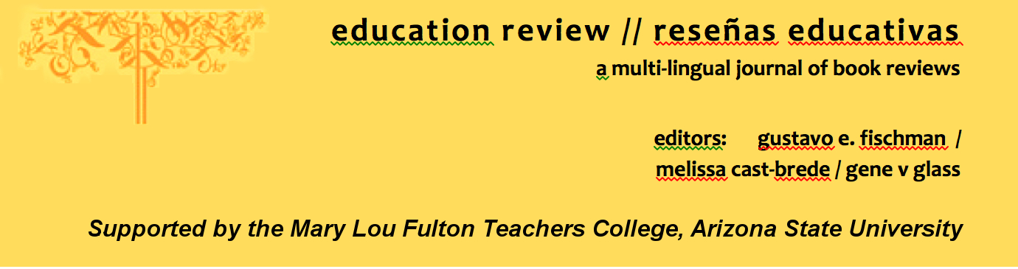
Education Review/Reseñas Educativas/Resenhas Educativas is supported by the edXchange initiative’s Scholarly Communications Group at the Mary Lou Fulton Teachers College, Arizona State University. Copyright is retained by the first or sole author, who grants right of first publication to the Education Review. Readers are free to copy, display, and distribute this article, as long as the work is attributed to the author(s) and Education Review, it is distributed for non-commercial purposes only, and no alteration or transformation is made in the work. More details of this Creative Commons license are available at http://creativecommons.org/licenses/by-nc-sa/3.0/. All other uses must be approved by the author(s) or Education Review. Education Review is published by the Scholarly Communications Group of the Mary Lou Fulton Teachers College, Arizona State University.

Please contribute reviews at http://www.edrev.info/contribute.html.

Connect with Education Review on Facebook (https://www.facebook.com/pages/Education-Review/178358222192644) and on Twitter @EducReview

