EdRev will insert date ISSN 1094-5296

Janis, S. E. (2016). Are you mixed? A war bride's granddaughter's narrative of lives in-between contested race, gender, class, and power. Charlotte, NC: Information Age Publishing, Inc.

Pp. 161 ISBN: 978-1-681233-87-1

Reviewed by Maya Fenty
Kent State University
United States of America
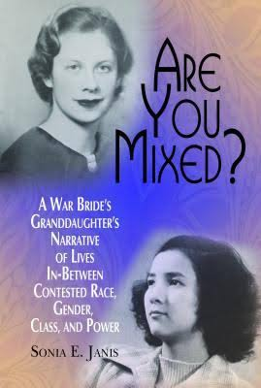

The process through which individuals’ identities evolve can no longer be explicated by simplistic categorical stages as early psychologists like Erik Erikson (1968) and James Marcia (1966) explained to their contemporaries. The nature of individuals’ identity, be it personal or social, is extremely complex. One approach to this complexity has been developed by cultural theorists such as Stuart Hall (1990), Gayatri Spivak (1994), and Homi Bhabha (2004). They developed an anti-essentialist approach to identity by using the term hybridity. Rather than emphasizing the mixture of two specific categories, hybridity represents the fusion of many differences, including one’s race, ethnicity, culture, language, religion, and even one’s sense of the belonging to a space. Although such fusion seems to be widespread around the world, our societies and educational environments still find ways to ostracize people who look a certain way, speak a different tongue, or have different belief systems. Such discriminatory occurrences could not have been better portrayed than by author Sonia Janis in her book Are you mixed? A war bride's granddaughter’s narrative of lives in-between contested race, gender, class, and power.
Are you mixed? features the author’s social justice research on life in schools, families, and communities. Janis’ inquiry is passionate and participatory, and she connects the personal with the political, the theoretical with the practical, and research with social and educational change. With her life stories, Janis explores the spaces in-between race and place from the perspective of a multiracial educator. As she reflects on her own experience, she realizes the complexity of situating herself in predetermined demographic categories. Her personal stories challenge educators, administrators, and policymakers to remove predetermined categories and stereotyped classifications when viewing the students of different or multiple cultural and racial backgrounds. By doing so, the author aims to inspire teachers and other stakeholders participating in students’ education process to commit to creating and enacting educational and social change that fosters equity, equality and social justice.
Janis embarks on her journey of writing this book by explaining who she is racially and culturally (one-half Polish, one-quarter Russian, and one-quarter Japanese), which leads to a discussion of the existing multicultural landscape of education in schools. The author introduces the concepts of race, racism, and multiculturalism, and the interplay between her analysis and application of these concepts within the context of her own experiences demonstrates how literature on multicultural education does not adequately address the phenomena of living in-between and multiple races. The author also questions the limitation of teachers’ deep cultural understandings of multicultural education. For instance, she describes an occasion when a teacher, who seemed to fear having an open and honest conversation about race in the classroom, found ways to avoid contradictions by just omitting the discussion of race entirely.
For Janis, having a silent educator is worse than having an inadequate educator. Thus, Janis calls all educators to action by narrating her experiences as a young student, as a young woman, and as an adult professional. Her stories highlight her own views on gender and religion, power hierarchies in the society, and her multiple races, and her stories are enveloped in broader themes like incongruence, imposition, agency, and advocacy.
For example, when Janis was in the middle school, her family moved from metro-Chicago area to Alabama. In the book, she reflects on her interpretations of her own relationships with Black and White people as a middle school student and how there were tremendous differences between the way people of Color were perceived in the Midwest and the South. She explains her struggles with inequality that she experienced as a student and a teacher in the South and examines retrospectively her reactions to racial and cultural misunderstandings. She recalls, “there is an awkward, disjointed, slow progression of my willingness to verbally express my ideas, which derive from my multiracial space in-between” (p. 46).
Janis' experiences with race were unique in the sense that she looks White and people who don't know her well perceive her as a White woman. However, from her stories this reader ascertained how her sense of belonging within the space of race is not the same as what others might perceive about her. As one-half Polish, one-quarter Russian, and one-quarter Japanese, her constant struggles with her race were not so much visible to her acquaintances or colleagues, but mainly visible to herself.
As Janis moved around as a student and then as an educator, she observed how each school she was involved with was culturally different. As she notes, her movement to say something about the unfairness she witnessed at certain points in her life was slow. Nevertheless, there was a progression. As Janis became an educator and later an administrator, she practiced her agency to advocate for others. The author chronicled her move from feeling like having no voice or position to advocating for those who are in need. In the book, Janis’ exploration of another complex component of her life-- being in an interracial marriage and living in the suburban South–led to her recollection of stories about when she faced people at her church or randomly in the park who did not understand or accept interracial unions. She even wondered if living in such environment led her, at least in part, to divorce her husband after six years.
As an administrator, Janis witnessed various inequities in the school system. She hoped to make change once in a higher position of authority. However, she realized in no time how negotiating the patriarchal system was discouraging and the obstacles to confront injustices were more powerful than her ability to make change. One of Janis' stories involved her talking to a mixed student and requesting him to check his ethnicity and race in a school document. She analyzed her internal controversial feelings about her actions, but concluded that she could not avoid the situation, which was required by the administration.
As a reviewer, I have seen how auto-ethnographic studies often receive criticism for lacking scholarship. Here, however, Janis justified and rationalized every step taken for this volume and aligned her narratives with extant literature. Reflecting on the theoretical traditions in curriculum studies, Janis clarifies: “I am not interested in trying to fit my multiracial identity development into a prescribed stage…” (p. 126). She claims that most of the curriculum studies scholarship does not address the notion of being “in-between” and since it flows from many spaces, such a notion cannot be explicated within one theoretical framework.
To argue her claim, Janis explicates how multirace is an interdisciplinary, cross-disciplinary, and counter-disciplinary area of study. Tracing the history of the study of multirace in relation to multicultural education and critical race theory, she delineates how a multiracial woman's narrative is related to both White women and women of color. Janis’ work has the characteristics of narrative inquiry and autobiography, as she combines the methods of narrative and memoir together to create a space for a new multiracial voice. While the volume was fluid and an enjoyable read, I would have liked discussions about the theories related to the concept of “in-between” and of “multirace” at the beginning of the volume, that is, be informed about these pertinent discourses before embarking on the narratives.
A unique contribution to curriculum studies, this volume offers an interdisciplinary perspective of multirace and reveals the need to bring more multiracial studies into conversations about education and curriculum. I recommend the volume Are you mixed? to teachers and administrators who influence students’ lives within school and classroom settings. In particular, Janis’ stories illuminate how South and Southern schools view multiracial individuals, but considering the diversity of U.S. schools, the book would be relevant to educators across the country. Learning about the struggles and experiences of multiracial individuals may promote more awareness, inclusivity, understanding, and empathy in schools. I also recommend this volume to multiracial students, as these stories may empower them to thrive in an increasingly complex and multicultural world.

References

Bhabha, H. (2004). The location of culture. London, UK: Routledge.
Erikson, E. H. (1968). Identity: Youth and crisis. New York, NY: W. W. Norton.
Hall, S. (1990). Cultural identity and diaspora. In J. Rutherford (Ed.), Identity: Community, culture, difference (pp. 222-237). London, UK: Lawrence & Wishart Limited.
Marcia, J. E. (1966). Development and validation of ego-identity status. Journal of personality and social psychology, 3(5), 551.
Spivak, G. C. (1994). Can the subaltern speak? In P. Williams & L. Chrisman (Eds), Colonial discourse and post-colonial theory: A reader (pp. 66-111). New York, NY: Columbia University Press.

About the Reviewer

Maya Fenty is currently a Ph.D. candidate in Cultural Foundations of Education at Kent State University. Maya’s research focuses on women’s identity construction after crossing cultural, geographical, and psychological borders to pursue a higher education in the United States. Her general research interests include identity, hybridity, post-colonial and globalization scholarships, multicultural education, and gender studies.

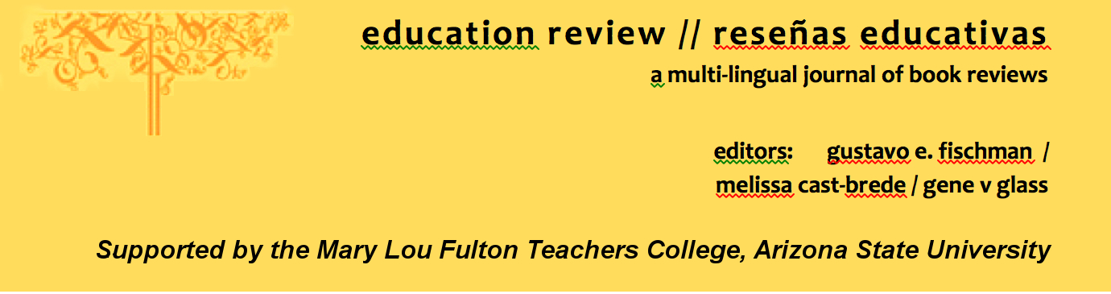
Education Review/Reseñas Educativas/Resenhas Educativas is supported by the edXchange initiative’s Scholarly Communications Group at the Mary Lou Fulton Teachers College, Arizona State University. Copyright is retained by the first or sole author, who grants right of first publication to the Education Review. Readers are free to copy, display, and distribute this article, as long as the work is attributed to the author(s) and Education Review, it is distributed for non-commercial purposes only, and no alteration or transformation is made in the work. More details of this Creative Commons license are available at http://creativecommons.org/licenses/by-nc-sa/3.0/. All other uses must be approved by the author(s) or Education Review. Education Review is published by the Scholarly Communications Group of the Mary Lou Fulton Teachers College, Arizona State University.

Please contribute reviews at http://www.edrev.info/contribute.html.

Connect with Education Review on Facebook (https://www.facebook.com/pages/Education-Review/178358222192644) and on Twitter @EducReview

