EdRev will insert date ISSN 1094-5296

Tobin, R. M., & House, A. E. (2016). DSM-5 diagnosis in the schools. New York, NY: The Guilford Press.

Pp. 268 ISBN: 978-1-4625-2372-6

Reviewed by Daniel J. Trunk
Beavercreek City Schools
United States

Among the myriad roles and responsibilities of teachers, administrators, and other school personnel in K-12 settings, helping students develop socially and emotionally are fundamental priorities. It seems now more than ever that children and adolescents are experiencing greater levels of inter- and intrapersonal distress that impact their learning, their relationships, as well as their adaptive functioning in schools and at home. Whether a result of biological factors, environmental conditions, or advances in research leading to more accurate and potentially more inclusive diagnoses, the rates of psychopathology in children and adolescents continue to rise, as does the need for comprehensive home, school, and community intervention.
Despite the common goal of accurate assessment and identification of child and adolescent functioning, the Individuals with Disabilities Education Improvement Act (IDEA) and Diagnostic and Statistical Manual of Mental Disorders, Fifth Edition (DSM-5; American Psychiatric Association, 2013) provide vastly 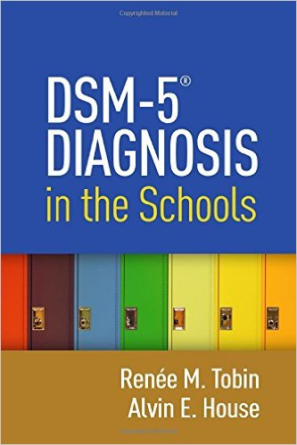different frameworks for diagnostic decision-making. Complicating matters, although often required to interpret outside reports and evaluations, school-based mental health practitioners may have little formal training addressing the structure of the DSM-5 or the philosophical assumptions behind the manual.
Tobin and House (2016) wrote DSM-5 Diagnosis in the Schools as a guide to help familiarize school-based practitioners with DSM and to help bridge the gap between school and clinical realms, especially with regard to diagnoses and treatment planning. Understanding differences between the clinical and school settings, the book is “intended to increase school-based practitioners’ familiarity with DSM-5 and to bolster their confidence in using it within school settings” (Tobin & House, 2016, p. 1). Based on my review of the book, I feel the authors succeeded in this intention.
As a school psychologist practicing in the public K-12 setting, much of my work involves helping children and their families identify barriers to development and academic achievement and to collaborate in the development of intervention plans containing strategies to help increase prosocial behaviors and academic skills. Within this setting, psychoeducational evaluations are conducted in accordance with the IDEA, predominately for the purpose of determining eligibility for special education and related services.
In clinical settings, however, psychiatric diagnoses made using DSM-5 are not necessarily tied to school or community-related services, regardless of the nature and severity of the disorders in consideration. As to child mental health, this dichotomy between diagnoses in school and in clinical settings can be a source of confusion and misinterpretation for mental health professionals in public and private settings, school officials, and families alike.
In order to understand and appreciate the unique lens with which the Tobin and House’s book was written, I think it is important to note that both authors have practical experience working with and assessing children and adolescents in both the clinical and school settings. Their comfort in the practical applications of DSM-5 and the IDEA across multiple settings was evident from the expertise conveyed throughout the text. The authors clearly articulated how practitioners can utilize DSM-5 as a resource in the school setting in order to more accurately understand particular challenges that students may face, as well as to formulate appropriate interventions and treatment plans based on unique learning needs.
Summarizing DSM-5 Diagnosis in the Schools, the chapters were divided into three sections with each providing a unique perspective of its application of DSM-5 in school settings. Given readers’ varying levels of DSM competency and the growing necessity for DSM proficiency in those who provide mental health services in school settings, Part I of the book began with an overview of psychiatric diagnosing in clinical settings and how these may be applicable to school settings. The authors discussed considerations for working with and/or diagnosing children with psychiatric disorders, again with relevance towards school practitioners. For those with little formal training using DSM-5, or for those who are familiar with previous editions of the manual which use a different diagnostic coding system, Tobin and House provided a clear and concise overview that may help the reader begin to build comfort and competence with the manual in Part I.
The authors also discussed the diagnostic system of the manual, and how this system differs from systems used in previous editions, such as the, multiaxial system. The authors defined and clarified the language frequently used in diagnoses, including such terms as diagnostic subtypes and specifiers to “rule out” diagnoses, as well as described processes for understanding and interpreting the severity of symptoms in children with multiple diagnoses. In my own practice, especially given verbiage changes in the newest edition of DSM, I have often been confused by some of the nuanced language contained in psychiatric and psychological assessment reports provided by private clinicians, which the first section of this book helped to clarify.
Moving from a broad description of the framework of DSM-5, Part II of Tobin and House’s book provided a more explicit discussion of diagnostic criteria for disorders frequently seen in school-age children. Themes of disorders, broken up into chapters, included: problems with intellectual ability and cognition; learning, communication, and motor problems; highly atypical symptom patterns; mood problems; anxiety problems; other internalizing problems; problems with conduct; problems with impulse control; highly focused symptom patterns; substance-related problem and other addictive behaviors; and personality disorders. The authors also included a chapter containing information on “Other Conditions That May Be a Focus of Clinical Attention” which included, as the name implies, conditions impacting the functioning of a child that may not necessarily meet criteria for or be considered mental disorders on their own.
The final section of the book addressed issues that may arise in practice relating to the application of DSM-5 in school settings. For example, the authors provided a brief overview of ethical storage of educational and mental health records, as well as billing and reimbursement practices and recommendations. Of particular relevance to special education evaluation and eligibility, the authors compare and contrast the underlying theoretical perspectives of the DSM-5 and IDEA. Finally, the book ended with a thought-provoking discussion of how society views mental illness from the standpoint of DSM-based diagnosing in children and youth. Counterintuitively, “[i]t is the endeavor of classifying human problems itself that is seen as fraught with negative consequences for those we wish to assist” (p. 231). The authors proclaimed that we must remain mindful of the limitations of diagnostic classification systems and the potential negative consequences that may accompany mental illness diagnoses.
Frequently throughout the text the authors provided six types of supplemental sidebar notes, as they called them, to “draw certain issues to the reader’s attention” (p. 5). Breaking up some of the more technical information, these items were both informational and thought-provoking. Coding Notes provided clarification and common areas of error related to psychiatric diagnosing, while Application Notes helped explain how school-based practitioners can interpret outside diagnoses and provided guidance for what these diagnoses may mean in the school setting and the implications the symptoms of the diagnoses may have in the school setting. Together these notes helped clarify distinctions in DSM-5 diagnostic criteria and diagnoses, as well as academic, behavioral, or adaptive functioning that may be expected in a child or adolescent with a particular diagnosed disorder.
Professional Notes, DSM-IV-TR Notes, and Author Commentaries sidebar notes were also incorporated throughout the chapters of the book. Professional Notes aimed to “identify both essential elements of competent practices and exemplary levels of professional care” (p. 5). Encompassing a wide range of issues practitioners may face, these notes included everything from recommendations for properly documenting a previously diagnosed medical condition to suggestions for ethical maintenance of psychological records. Given both subtle and substantive changes from DSM-IV-TR to DSM-5, the DSM-IV-TR Notes provided useful and concise summaries of specific changes to the new edition of the manual. For practitioners with experience using previous editions of DSM, there may have been questions and growing pains associated with adapting to the new version. The Author Commentaries were very helpful in clarifying some of the more complex or even gray areas of the DSM. In these annotations, the authors provided a blunt analysis of topics and concepts related to diagnosis and treatment in the manual based on their own experiences in the field. These commentaries also provided guidance on interpretation of some of the vague concepts and language in DSM.
Finally, and perhaps most relevant to the traditional role of the school psychologist, the authors included IDEA Notes which illustrated how various DSM-5 diagnoses align with IDEA special education categories. Broadly stated, insofar as qualifying for services under the IDEA is a more stringent process than having Mental Disorders under DSM-5 criteria, trying to fit DSM diagnoses into IDEA eligibility frameworks can be difficult. Muddying the waters, the authors pointed out “that some children with a DSM-5 diagnosis of a Mental Disorder are not deemed eligible for services under IDEA and some children who are eligible for services under IDEA do not have a Mental Disorder as defined by DSM-5” (p. 229). These author notes help provide guidance for school-based practitioners as they consider how clinical diagnoses may apply to IDEA evaluations and services.
The biggest strength of DSM-5 Diagnosis in the Schools is its overall practical utility for mental health professionals in the school setting. Given school psychologists may have expertise in making special education eligibility decisions using IDEA guidelines, but may have less experience making and understanding diagnoses per the DSM-5, this text provided a nice overview of the purposes of the DSM-5 and how practitioners reach diagnostic decisions. Whereas it may be daunting for those with limited DSM experience to read the over- 800 page text from cover to cover, this book provided a nice introduction to the DSM and its practical application in schools.
With that being said, DSM-5 Diagnosis in the Schools neither replaces the DSM-5 for use in clinical or school settings nor serves as a sufficient training tool for competence in DSM-5 diagnosing. As the authors commented, the book does not replace DSM-5, and that “a copy of DSM-5 should be readily available in each setting in which diagnoses are formulated” (p. 3). As such, for practitioners with little prior DSM training, the text should only be used as a resource to help better understand the philosophy behind the DSM and to better meet the needs of students who may have outside DSM diagnoses. For those practitioners responsible for conducting psychiatric assessments and making DSM diagnoses, the book should be used as a supplement to the DSM-5 text and more formal training.
Based on my experiences working in schools over the past 10 years, I believe the DSM-5 Diagnosis in the Schools is now more relevant and useful than ever for helping meet the needs of children and adolescents with psychiatric disorders in school settings. As the authors stated, “psychiatric diagnosis has increasingly become part of the task of school psychologists” (Tobin & House, 2016, p. 10). As such, the need for school psychologists as well as other mental health professionals working in school settings to have comfort and competence in using the DMS-5 is of growing importance. I highly recommend DSM-5 Diagnosis in the Schools as an excellent resource for school psychologists and other school-based mental health practitioners interested in not only better understanding the newest version of the DSM, but also in helping meet the unique needs of the students they serve.

References

American Psychiatric Association. (2013). Diagnostic and statistical manual of mental disorders (5th ed.). Arlington, VA: American Psychiatric Publishing.

About the Reviewer

Daniel J. Trunk, Ph.D.
School Psychologist
Beavercreek City Schools

Dr. Daniel Trunk is a nationally certified school psychologist and adjunct faculty member in the School of Education and Health Sciences at the Univeristy of Dayton. His professional and research interests include the needs and experiences of students with impairments in K-12 and higher education settings and organizational behavior and change.
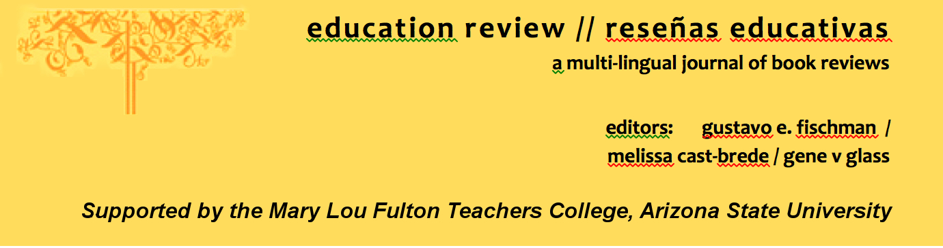
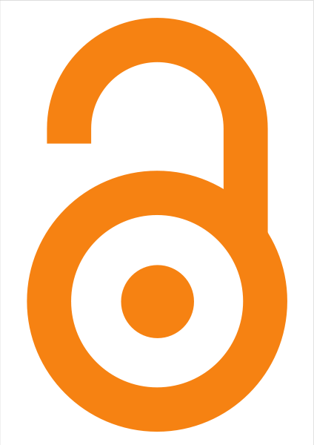
Education Review/Reseñas Educativas/Resenhas Educativas is supported by the edXchange initiative’s Scholarly Communications Group at the Mary Lou Fulton Teachers College, Arizona State University. Copyright is retained by the first or sole author, who grants right of first publication to the Education Review. Readers are free to copy, display, and distribute this article, as long as the work is attributed to the author(s) and Education Review, it is distributed for non-commercial purposes only, and no alteration or transformation is made in the work. More details of this Creative Commons license are available at http://creativecommons.org/licenses/by-nc-sa/3.0/. All other uses must be approved by the author(s) or Education Review. Education Review is published by the Scholarly Communications Group of the Mary Lou Fulton Teachers College, Arizona State University.

Please contribute reviews at http://www.edrev.info/contribute.html.

Connect with Education Review on Facebook (https://www.facebook.com/pages/Education-Review/178358222192644) and on Twitter @EducReview

