mEdRev will insert date ISSN 1094-5296

Sahlberg, P., Hasak, J., Rodriguez, V. and Associates. (2017). Hard questions on global educational change: Policies, practices, and the future of education. New York, NY: Teachers College Press.
Pp. 136 ISBN: 9780807758182

Reviewed by Mark J. Oromaner
Independent Scholar
United States

References

Oromaner, M. J. (2018, January 17). Review of News media and the neoliberal privatization of education, by Z. C. Wubbena, D. R. Ford, & B. J. Porfilio (Eds.). Education Review, 25. http://dx.doi.org/10.14507/er.v25.2304.
Wubbena, Z. C., D. R. Ford, & B. J. Porfilio (Eds.). (2016).News media and the neoliberal privatization of education. Charlotte, NC: Information Age Publishing.
Zumeta, W., D. W. Breneman, P. M. Callan, J. E. Finney (Eds.). (2012). Financing American higher education in the era of globalization. Cambridge, MA: Harvard Education Press.
About the Reviewer
Mark Oromaner is an independent scholar (sociology). He spent more that 35 years in higher education as a faculty member, administrator, and researcher. His major research interests and publications focus on the sociology and history of higher education and of the social sciences. His research has appeared in journals such as The American Sociologist, Community College Review, British Journal of Sociology, Research on Higher Education, Philosophy of the Social Sciences, Social Studies of Sciences, and Knowledge: Creation, Diffusion, Utilization. In addition, he has written numerous book reviews on public education and education policy.

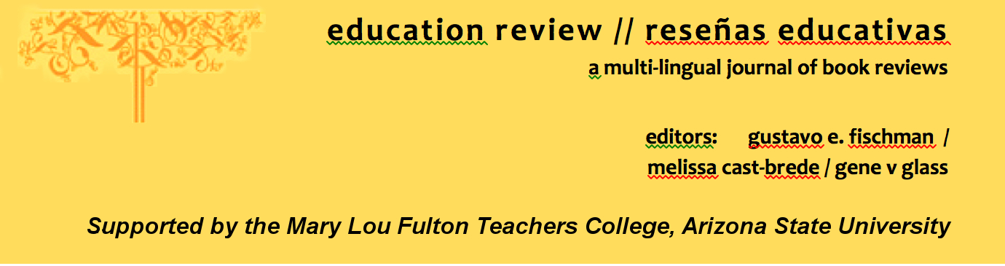
Education Review/Reseñas Educativas/Resenhas Educativas is supported by the edXchange initiative’s Scholarly Communications Group at the Mary Lou Fulton Teachers College, Arizona State University. Copyright is retained by the first or sole author, who grants right of first publication to the Education Review. Readers are free to copy, display, and distribute this article, as long as the work is attributed to the author(s) and Education Review, it is distributed for non-commercial purposes only, and no alteration or transformation is made in the work. More details of this Creative Commons license are available at http://creativecommons.org/licenses/by-nc-sa/3.0/. All other uses must be approved by the author(s) or Education Review. Education Review is published by the Scholarly Communications Group of the Mary Lou Fulton Teachers College, Arizona State University.

Please contribute reviews at http://www.edrev.info/contribute.html.

Connect with Education Review on Facebook (https://www.facebook.com/pages/Education-Review/178358222192644) and on Twitter @EducReview

