EdRev will insert date ISSN 1094-5296

Holme, J. J., & Finnigan, K. S. (2018). Striving in common: A regional equity framework for urban schools. Harvard Education Press.
Pp. 168 ISBN: 978-1-68253-252-2

Reviewed by Akua Nkansah-Amankra
University of Southern California
United States
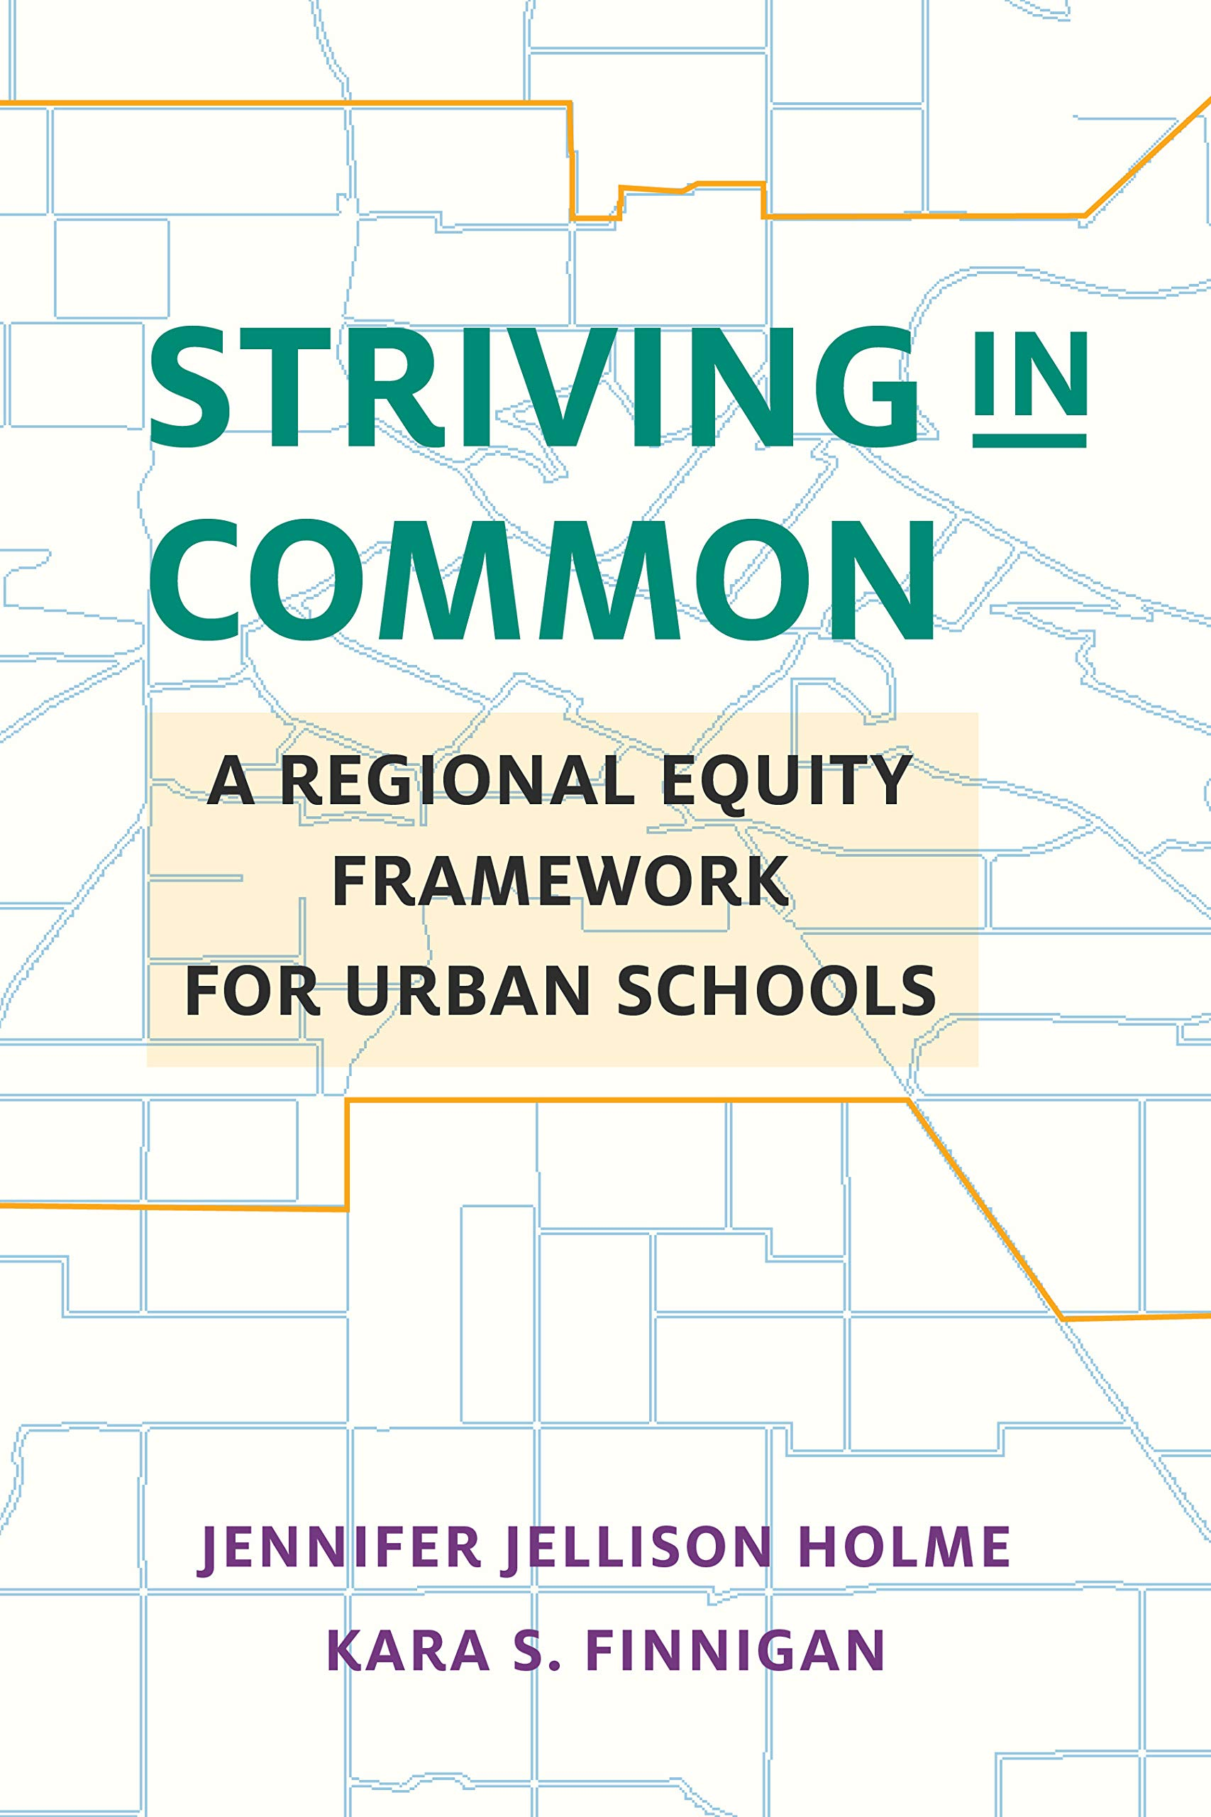

For the better part of the 21st century, conversations about inequalities in K-12 academic outcomes have attributed the lower performance of marginalized urban students of color to limited student effort, low teacher quality, supposed lack of parental investment, and bureaucratic inefficiencies (Darling-Hammond, 2007). Likewise, policy solutions have focused on increasing accountability among various stakeholders, in the form of high-stakes testing, value-added models, truancy arrests, and even school closures. However, Striving in Common: A Regional Equity Framework for Urban Schools proposes a different approach for establishing equity in education. Authors Jennifer Jellison Holme and Kara S. Finnigan argue that observed educational outcomes are the result of historical resource inequalities as well as racial and economic segregation, which have placed segregated, high-poverty districts at a continued disadvantage. Through interviews and historical analyses of 20th-century foundational housing and education policies, the authors highlight the systemic nature of regional inequality, and argue for a broader, cross-sector policy approach that transforms the entire education and urban reform landscape.
In the first section, the authors use school attendance and quality data to paint a picture of the current educational landscape that is widely supported by other research studies: Black and Latinx students are more likely to attend segregated schools that are under-resourced and under-performing as compared to white students. In addition, these students of color are more likely to come from low-income households and live in segregated neighborhoods of concentrated poverty. The authors then argue that the prevailing education policy reform approach, which prioritizes accountability measures, exacerbates problems of educational equity. This approach does not challenge the underlying systems of segregation and resource inequality that created education inequities, causing low-performing schools to be further penalized. Using a political geography framework, the authors argue that rather than blaming low performing schools, the focus should be on addressing the racial and economic segregation that is at the root of the issues attacking urban schools. Essentially, resource equity in schools is hardly isolated and is in fact tied to many other aspects of urban living.
To make their argument for a comprehensive approach to addressing education inequities, Holme and Finnigan used data from a case study that they conducted between 2008 and 2012 on inter-district integration programs in eight American cities of varying size, socioeconomic status, and racial/ethnic composition. The cities included in the study, whose school integration policies were implemented as early as 1964 and as late as 2007, were: Chicago, IL; Hartford, CT; Milwaukee, WI; Minneapolis, MN; Omaha, NE; Palo Alto, CA; Rochester, NY; and St. Louis, MO. The study showed that even as integration efforts began in cities, federal and local policies continued to systematically exclude people of color from building wealth and thus political power, thereby facilitating disparities in school resource allocations. Holme and Finnigan also discuss how Supreme Court cases helped to legitimize and entrench de facto segregation in housing and education. After tracing the development of de facto segregation, the authors review integration policies and show that integration programs as currently constructed don’t challenge these underlying systems of oppression that perpetuate patterns of unequal access. The authors use extant research as well as their own data analysis of integration programs to show that while some of these policies led to marginal improvements for some students of color, overall resources and political power continue to be concentrated geographically within rich white communities. Holme and Finnigan argue that because segregation results from rich white communities systematically isolating low-income, predominantly Black and Latinx communities (and thereby, students) from political and economic opportunities, integration can only effectively work if those white communities are willing to share resources and power.
From their research, the authors find that while consolidating city and suburban governments was the most effective at reducing inequality, resistance from both suburban and city communities eventually undermined those efforts. Because of these local politics, they recommend a federated regional approach to school reform. Such an approach allows different cities to collaborate to address related issues of housing and school segregation and resource inequality across city boundaries, while maintaining their own sovereignty. Their vision for the uses of a federal regional equity approach includes the following:

- tax-base sharing in order to equitably distribute tax base growth across the whole region and reduce intra-district competition;
- place-based policies which provide investment and resources to high-poverty and historically marginalized communities;
- mobility policies to reduce racial and economic segregation of resources by fostering policies that allow people to easily move across boundary lines;
- regional governance, which allows a group of elected representatives from all communities in the region to oversee the implementation and maintenance of the shared vision of regional equity; and
- cross-sector approaches, “where educational policy is…pursued…in tandem with housing, transit, health, economic development, etc.” (p. 111).

The writing is compelling and accessible, and the authors re-envision policy solutions that connect equity issues across sectors of housing, education, and healthcare. Community activists and critical policy researchers have long called for cross-sector approaches long before this book, but Holme and Finnigan synthesize various sources of evidence to bolster arguments made by activists. For example, the authors build on the work of scholars like Eve L. Ewing and Natalie Y. Moore, who show how systematic discriminatory education and housing policies against Black people in Chicago created the conditions for low academic achievement in Black schools, despite strong community support for students. Holme and Finnigan also masterfully leverage discourse, policy, and legal analysis grounded in a political geography framework, and use geospatial maps to highlight various resource inequities at the different study sites.
Perhaps the biggest shortcoming of this book is that the authors sidestep how neoliberal ideologies inform the policies that have exacerbated inequity in education and urban environments. The last half-century has seen a surge of policies promoting deregulation, privatization of public services, and “free-market” economics, the argument being that freeing the market from government intervention will promote competition and economic growth among all aspects of social life: economics, schooling, housing, healthcare, to name a few (Blakely, 2017). In education policies, we see this logic reflected most in technical reforms that promote standardized testing and school choice under the guise of fostering competition in the education marketplace. In actuality, because a neoliberal logic does not attempt to level the playing field by addressing the effects of systematic discrimination, the minority of well-resourced rich, white people and communities continue to hoard more resources at the expense of those in low-income, racially-minoritized communities (Ross & Gibson, 2007).
With a critical lens toward neoliberalism, we start to question the sustainability of Holme and Finnigan’s race-evasive policy solutions that advocate for increased government intervention and cross-sector collaborations between suburbs and urban cities. We even see that in the regional equity programs that they discussed, the authors observed that despite the overall success of these programs, rich, white stakeholders used race-evasive language to eventually undermine these programs at the expense of Black and Brown communities. Inequities in education, housing, and healthcare are not happenstance consequences of some “broken” system, but rather inherent features of the structure itself. Therefore, it is important to center a structural analysis of the economic and political forces that have created and perpetuated these inequitable systems.
In addition, the authors seem to have a surprisingly optimistic tone about improving resource distribution, despite their (and others’) acknowledgement of how racism along with economic self-interest has created and perpetuated racially disparate outcomes in education. They suggest that once rich, white communities realize that resource inequities negatively impact them as well, and that resource equity is not a zero-sum game for their children, they would be more likely to participate in the systematic reform that the authors advocate for. However, racism is not as simple as an “us versus them” problem, nor is it a recent problem that has been dragged “from the far reaches of the country…[into] our national politics” (p. 128). Several critical scholars of race and education, including Derrick Bell, William F. Tate, and Gloria Ladson-Billings, have argued that racism is built into the very core of the United States. Recently, the 1619 project (2019) headed by Nikole Hannah-Jones demonstrated how U.S. market and government can be traced back to (and in many ways, is based upon) the subjugation of Black people. Racism and white supremacy figure prominently in the opposition to equitable education reforms in ways that aren’t simply a matter of converging the interests of racially minoritized people with those of white people, so a race-evasive regional equity approach will continue to fail Black and Brown communities.
Striving in Common provides a strong argument for analyzing education inequality within the context of inequitable housing, health, and economic policies. As the authors put it, piecemeal policy approaches to inequitable resource distribution are “like small sandbags trying to hold back a wall of water: they [are] ultimately unable to counteract the powerful economic tides” that make up the status quo (p. 18). This book could be beneficial to a wide variety of readers, including education and urban reform policymakers, researchers, educators, and potentially even community organizers interested in education reform. Future work could expand the framework to also include criminal justice, as this system has had implications for housing, schooling, and even political power in Black and Brown neighborhoods. It would be interesting to see how this work is taken up in both the policy and academic spaces, because of the ways that it challenges commonly-held assumptions and solutions that are used in diagnosing and solving issues of education inequality. Overall, the accessible writing makes it a worthwhile read for anyone looking to understand the origins of educational inequity in the US and how to transform the system to work for the interests of all students.

References

Blakely, J. (2017). How school choice turns education into a commodity. The Atlantic.https://www.theatlantic.com/education/archive/2017/04/is-school-choice-really-a-form-of-freedom/523089/
Card, D., & Rothstein, J. (2007). Racial segregation and the black–white test score gap. Journal of Public Economics, 91(11-12), 2158-2184.
Crosnoe, R. (2009). Low-income students and the socioeconomic composition of public high schools. American Sociological Review, 74(5), 709–730. https://doi.org/10.1177/000312240907400502
Darling-Hammond, L. (2007). Third Annual Brown Lecture in Education Research—The Flat Earth and Education: How America’s Commitment to Equity Will Determine Our Future. Educational Researcher, 36(6), 318–334. https://doi.org/10.3102/0013189X07308253
Ewing, E. L. (2018). Ghosts in the schoolyard: Racism and school closings on Chicago’s South Side. University of Chicago Press.
Ross, E. W., & Gibson, R. J. (Eds.). (2007). Neoliberalism and education reform. Hampton Press.
The 1619 Project. (2019). The 1619 Project. The New York Times. Retrieved from https://www.nytimes.com/interactive/2019/08/14/magazine/1619-america-slavery.html

About the Reviewer

Akua Nkansah-Amankra is an Urban Education Policy PhD student at the University of Southern California (USC), and a research associate with the Center for Education Policy, Equity, and Governance. They are a Ford Foundation Predoctoral Fellow, National Science Foundation Graduate Research Fellow, and a USC Provost Fellow. Their research interests include classroom management, school discipline policies and reforms, critical discourse analysis, and quantitative criticalism. They can be reached at nkansaha@usc.edu.

Education Review/Reseñas Educativas/Resenhas Educativas is supported by the Scholarly Communications Group at the Mary Lou Fulton Teachers College, Arizona State University. Copyright is retained by the first or sole author, who grants right of first publication to the Education Review. Readers are free to copy, display, and distribute this article, as long as the work is attributed to the author(s) and Education Review, it is distributed for non-commercial purposes only, and no alteration or transformation is made in the work. More details of this Creative Commons license are available at http://creativecommons.org/licenses/by-nc-sa/3.0/. All other uses must be approved by the author(s) or Education Review. Education Review is published by the Scholarly Communications Group of the Mary Lou Fulton Teachers College, Arizona State University.

Disclaimer: The views or opinions presented in book reviews are solely those of the author(s) and do not necessarily represent those of Education Review.

Connect with Education Review on Facebook (https://www.facebook.com/pages/Education-Review/178358222192644) and on Twitter @EducReview

