EdRev will insert date ISSN 1094-5296

Richardson, J. W. (2020). Bringing innovative practices to your school: Lessons from international schools. Routledge.

Pp. 220 ISBN: 978-0-367-18590-9

Reviewed by Eric Jabal
Collège de l’Ouest de l'Île / West Island College
Canada

In this Routledge Eye on Education book, Jayson W. Richardson brings together field-tested contributions from international school practitioners to highlight “cutting-edge educational innovations happening globally” and link these to teaching and leadership practices that “should and can occur in schools across the world” (p. xiii). The 32 authors provide a neat window into creative approaches to K-12 international school learning, teaching, and innovation. The lessons, strategies, and techniques offer vivid snapshots of innovative practices with the potential to be adapted in local school or district contexts.

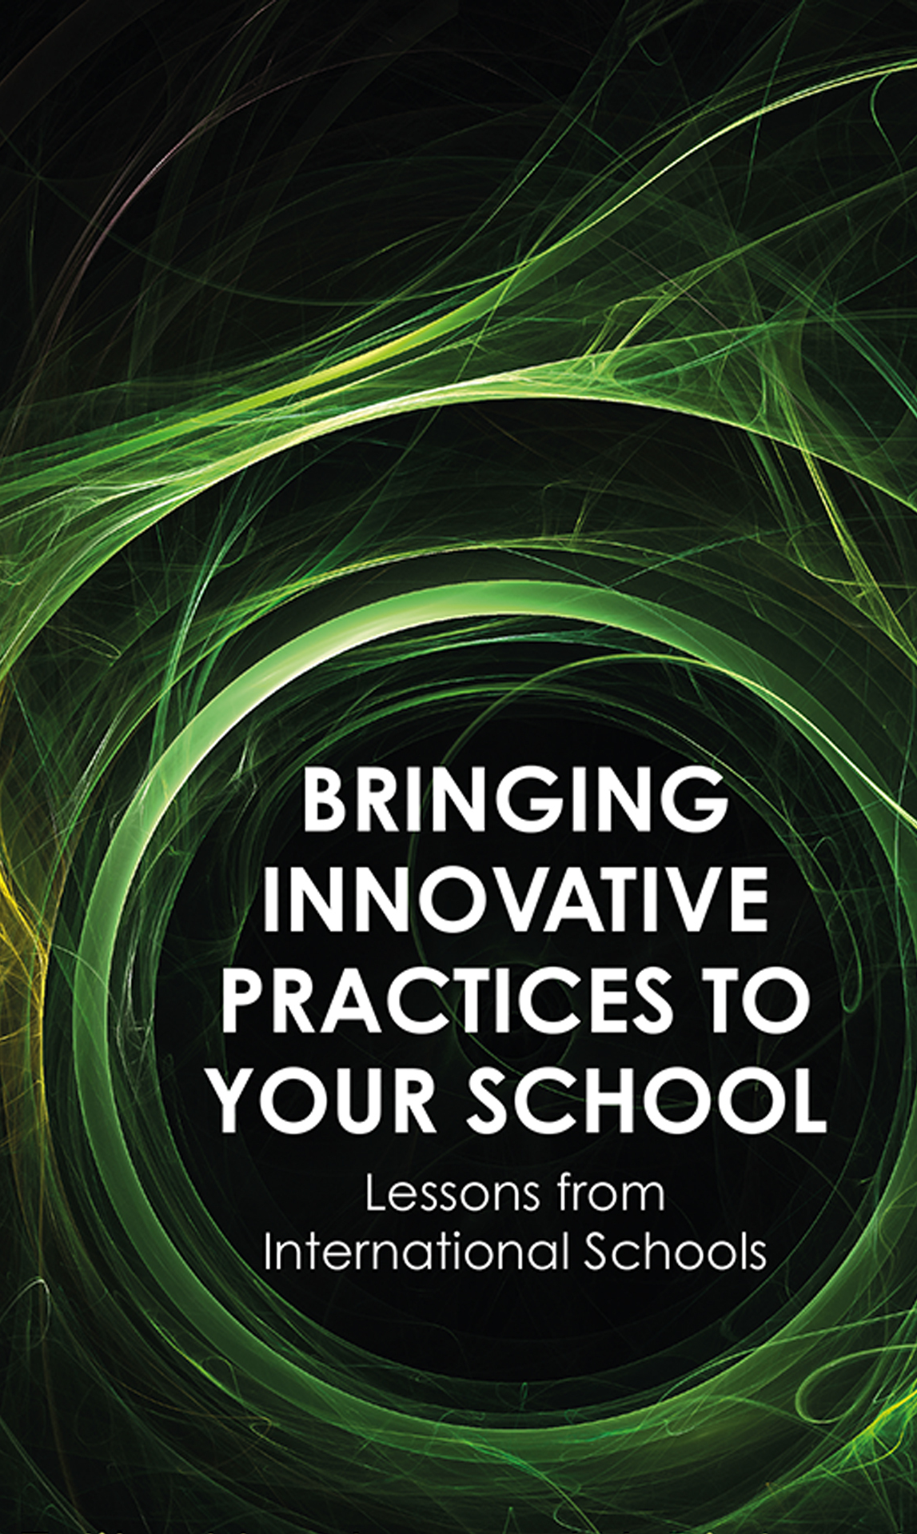
Sensitive to the interplay of global, cultural, and technological forces—as Chair of the Department of Educational Leadership and Policy Studies in the Morgridge College of Education at the University of Denver, Director of the Center for the Advanced Study in Technology Leadership, and Editor-in-Chief of the Journal of Educational Administration—Dr. Richardson is well-placed to focus his comparative, international, and development education lenses on this international schools arena, which is so often excluded from the mainstream discussion of education innovation. Given their complex communities and diverse, unique student bodies, how are innovative K-12 international schools preparing learners to be future-ready for a post-pandemic and ever-expanding digital world?

The edited collection is organised into six broad sections that explore: (a) student agency; (b) equity; (c) curriculum, teaching, and student learning; (d) management of schools; (e) teacher leadership; and (f) technology and school leadership. It features an introduction; biographies of contributors whose professional proving grounds span Chile, China, Colombia, Gambia, India, Japan, Singapore, South Korea, Tanzania, Thailand, Uganda, United States, and Vietnam; and 17 chapters and 5 vignettes. The user-friendly and intuitive index of main topics and key and related concepts (with valuable cross-referencing) make it easy to navigate the different parts of the book.

Each section has its own introduction that usefully links the different contributions to the topic at hand. The fairly short chapters and vignettes, which further contextualise the array of innovative practices, are clearly written, readily digestible, and suitably referenced in external resources. They walk readers through both process (ideation, introduction, and implementation) and outcome or impact of the innovative practices in international schools. In most cases, this also includes brief critical reflections on the merits and limitations of a given innovation, as well as some considerations for potential next steps. To help the text’s readability, a one-paragraph summary starts and a succinct ‘Innovative Leadership Practices’ conclusion ends each chapter and vignette. Through teasing out the leadership-innovatory takeaways that could be pursued in other (non-international) school contexts, readers are encouraged to take a global perspective and imagine applying it to their local context.

The varied educational settings add colour and reach to the thematic action case studies, with at least six interrelated keys to enact innovative change coming through:
- clarify and align an outcome-focused vision for social, emotional, academic learning supported by constructivist pedagogy and responsive school structures;
- cultivate the conditions for inquiry, reflection, and action through learning design that is flexible (expanding upon the principles of Universal Design for Learning);
- promote a “professional learning journey” perspective as an arc of growth, maturity, and renewal (because learning and progress are not always linear!);
- harness collective (i.e., teacher and leader) efficacy to strengthen existing systems-level approaches for stakeholder buy-in (“authorship is ownership”);
- patience—creating a sustainable culture of innovation takes time; and
- “We cannot expect student agency without teacher agency” (p. 152).

A culture of collaboration, characterised by a will and confidence to experiment to promote inquiry and to enhance student engagement and professional learning, infuses the different international school ecosystems that are, for example:
- rethinking student schedules (more self-directed time);
- co-constructing course content or structures (increase opportunity for student choice, shift from content-driven to skill-based curriculum and assessment);
- redesigning physical (e.g., classroom, playground) and digital spaces; and
- developing more equitable and effective staffing practices (e.g., instructional coaching, team norms).

Demonstrating constructivist principles in action, the varied snapshots highlight how and why taking the time to get input, actively involving stakeholders in the construction of understanding, and sharing of perspectives, is so important. As one contributor notes, “Often in school we jump to brainstorming solutions to problems without understanding if our solutions are addressing a cause or an effect. If our solutions address effects, our ideas don’t work, or they only work for a short period, leading to future frustration” (p. 140). As a set, the encouraging examples show schools that are intentionally reculturing and iteratively restructuring to make students “subjects” rather than “objects” of instruction (Freire, 2000), that is, part of a caring community of learners, all striving to author and connect their classroom learning to the curriculum of real life.

As a former international school teacher, middle leader, and principal—my path did cross some of the authors during my time as a Hong Kong-based volunteer evaluator and regional accreditation officer for the Council of International Schools—I found the portraits instructive, refreshing, and real. Though we know that the uncritical transfer of practice is rarely successful, aspirational educational leaders arguably share the same goal: for children to achieve academic success, but not at the expense of their holistic and character development; and to be ethical, passionate, and engaged in “deep learning” (Quinn et al., 2020). Much as the stories and guidance from Dr. Richardson and the contributors show that generating momentum to innovate is indeed “complex,” it does not have to be “complicated” (Cuban, 2010) or frustrating.

Despite the prevailing accountability mindset of modern education, schools can and should be places of learning through cultivating a culture of inquiry, reflection and growth, and action and impact—for children and adults alike. Running a school does not have to just be about cost-to-benefit numbers, rules, and buildings; it can be about “putting learning first and doing that through concerted efforts to empower others and share leadership” (p. 86). As evidenced, building capacity amongst stakeholders, trust through intentional communication of vision and values, and distributed leadership can strengthen relationships to amplify voice and agency for a more engaged school community.

In sum, this edited book is an important contribution to the field of educational administration with appeal to scholar-practitioners and school leaders, both local and international. It provides timely insights into mission-driven, learning-focussed schools that are innovating to connect classroom curriculum with relevant academic and post-school experiences. How important during the pandemic and beyond, with educators everywhere doing their level best to future-ready students for a world where the prevailing constant is change.

References

Cuban, L. (2010, June 8). The difference between “complicated” and “complex” matters [Blog post]. https://larrycuban.wordpress.com/2010/06/08/the-difference-between-complicated-and-complex-matters/

Freire, P. (2000). The pedagogy of the oppressed (30th anniv. ed.). Bloomsbury Academic.

Quinn, J., McEachen, J., Fullan, M., Gardner, M., & Drummy, M. (2020). Dive into deep learning: Tools for engagement. Corwin Press.

About the Reviewer
Dr. Eric Jabal is Head of School at Collège de l’Ouest de l'Île/West Island College (WIC), a bilingual high school in Montreal. Before joining WIC, Eric served as a Council of International Schools evaluation team visitor and accreditation officer based in Hong Kong. Since 1994, Eric has worked as a teacher and administrator in Europe and East Asia. Eric’s main research interests include student engagement, leadership for school improvement, and comparative and international studies.

Education Review/Reseñas Educativas/Resenhas Educativas is supported by the Scholarly Communications Group at the Mary Lou Fulton Teachers College, Arizona State University. Copyright is retained by the first or sole author, who grants right of first publication to the Education Review. Readers are free to copy, display, distribute, and adapt this article, as long as the work is attributed to the author(s) and Education Review, the changes are identified, and the same license applies to the derivative work. More details of this Creative Commons license are available at https://creativecommons.org/licenses/by-sa/4.0/.

Disclaimer: The views or opinions presented in book reviews are solely those of the author(s) and do not necessarily represent those of Education Review.

Connect with Education Review on Facebook (https://www.facebook.com/pages/Education-Review/178358222192644) and on Twitter @EducReview

